**Assignment 6: Composite Design Pattern**

**Class Diagram**

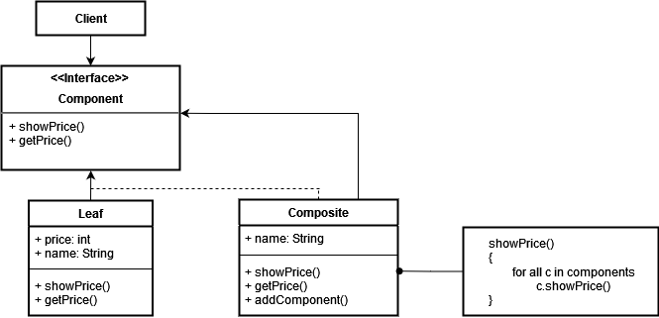

**Implementation (Code)**

* **Component.java**

interface Component {  
 void showPrice();  
 int getPrice();  
}  
class Leaf implements Component {  
 int price;  
 String name;  
 Leaf(String name, int price){  
 this.name = name;  
 this.price = price;  
 }  
 public void showPrice(){  
 System.*out*.println("Leaf -> " + name + " : " + price);  
 }  
 public int getPrice() { return price; }  
}

* **Composite.java**

class Composite implements Component{  
 String name;  
 List<Component> components = new ArrayList<>();  
  
 public Composite(String name) {  
 super();  
 this.name = name;  
 }  
 public void addComponent(Component com){  
 components.add(com);  
 }  
 public int getPrice(){  
 int p=0;  
 for (Component c : components){  
 p += c.getPrice();  
 }  
 return p;  
 }  
 public void showPrice(){  
 System.*out*.println("\nComposite -> " + name + " : Price " + getPrice());  
 System.*out*.println("Leaf of " + name + "\n[");  
 for (Component c : components){  
 c.showPrice();  
 }  
 System.*out*.println("]");  
 }  
}

* **CompositePattern.java**

public class CompositePattern {  
 public static void main(String[] args) {  
 Component flw = new Leaf("Front Left Wheel", 4000);  
 Component frw = new Leaf("Front Right Wheel", 4500);  
 Component rlw = new Leaf("Rear Left Wheel", 5000);  
 Component rrw = new Leaf("Rear Right Wheel", 4000);  
 Component piston = new Leaf("Piston", 9000);  
 Component chamber = new Leaf("Combustion Chamber", 8000);  
 Component camshaft = new Leaf("Cam Shaft", 10000);  
 Component valves = new Leaf("Valves", 8500);  
  
 Composite wheel = new Composite("Wheel");  
 Composite engine = new Composite("Engine");  
 Composite car = new Composite("Car");  
  
 wheel.addComponent(flw);  
 wheel.addComponent(frw);  
 wheel.addComponent(rlw);  
 wheel.addComponent(rrw);  
 engine.addComponent(piston);  
 engine.addComponent(chamber);  
 engine.addComponent(camshaft);  
 engine.addComponent(valves);  
  
 car.addComponent(wheel);  
 car.addComponent(engine);  
  
 car.showPrice();  
  
 }  
}

**Output:**

